 | 12.1.16 Editors - Geometry Nodes Editor - Header - Add Menu - Curve - Sample
Table of content
Detailed table of content 1
Add - Curve - Sample 6
Sample Curve 6

Detailed table of content
Detailed table of content
Detailed table of content 1
Add - Curve - Sample 2
Sample Curve 2
Input 2
Curve 2
Value 2
Mode Factor 2
Factor 2
Curve Index 2
Mode Factor 2
Factor 2
Length 2
Properties 3
Data Type 3
Sample Curve Mode 3
All Curves 3
Output 3
Value 3
Position 3
Tangent 3
Normal 3

Add - Curve - Sample
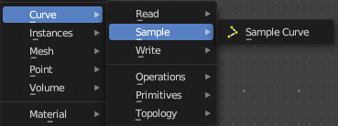
Here you find curve related nodes.

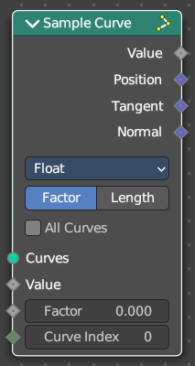
Sample Curve
Calculates a point on a curve at a certain distance from the start of the curve, specified by the length or factor inputs. It also outputs data retrieved from that position on the curve.
The sampled values are linearly interpolated from the values at the evaluated curve points at each side of the sampled point.
In case that the curve contains multiple splines, the sample position is found based on the total accumulated length, including the lengths of all previous splines. The order of the splines is the same order as displayed in the Spreadsheet Editor.

Input

Curve
The input geometry.

Value
Input Value.

Mode Factor

Factor
The resample amount with method Factor.

Curve Index
The curve index.

Mode Factor

Factor
The resample amount with method Factor.

Length
The resample amount with method Length.

Properties

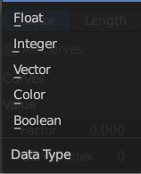
Data Type
What data to calculate.

Sample Curve Mode
How to calculate the curve. By a factor, or by its length.

All Curves
Sample lengths based on the length of all curves.

Output

Value
Output Value.

Position
The position at the sample along the spline.

Tangent
The normalized curve tangent at the sample.

Normal
The normalized curve normal at the sample.

